Volunteer Expression of Interest Form
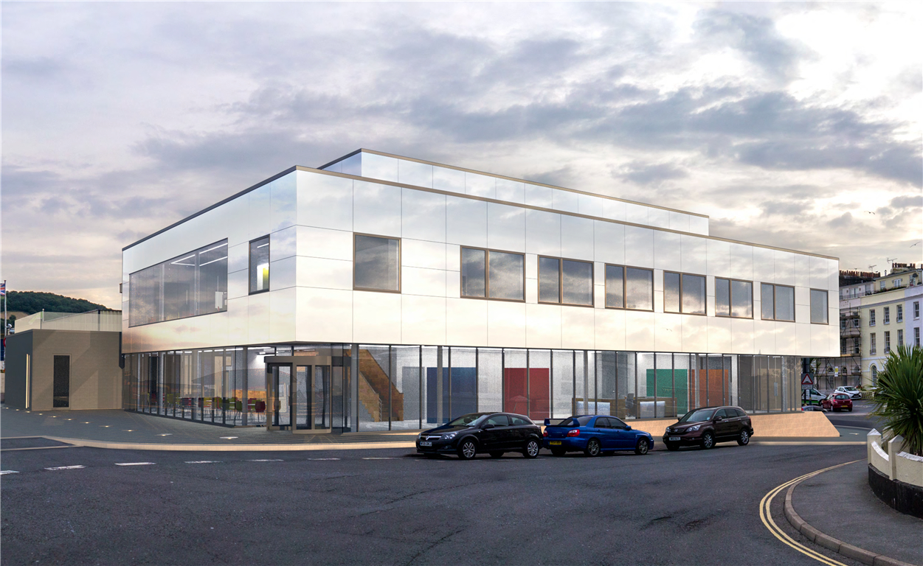
We welcome your interest in volunteering at Pavilions Teignmouth - please complete this form to tell us more about your areas of interest and availability.
Name ……………………………………………………….
Address ……………………………………………………
………………………………………………………………
Email address ……………………………………………
Telephone Number ………………………………………
Mobile Number …………………………………………..
Seeking ad-hoc volunteering? YES/NO
Seeking regular volunteering? YES/NO (please indicate days/times)…………………………………………………
Please give your age if under 18……………………….

Tick | Areas in which volunteers can get involved
 | Stewarding films & live events and gallery exhibitions
 | Stewarding children's films & workshops
 | Selling merchandise and programmes
 | Box Office – reception & ticketing
 | Front of House - ensuring audience wellbeing and smooth running
 | Marketing & PR activities incl social media, members, friends
 | Business development (sponsorship & grant applications)
 | Fundraising events
 | Administration eg photocopying, mailouts, databases, IT
 | Support with professional skills eg legal, HR, accounts
 | Supporting Technical team backstage
 | Showing films - operating digital projectors
 | Practical skills eg. carpentry, painting & decorating
 | Qualified skills in plumbing or electrical wiring
 | Visitor Information Centre – welcoming and guiding visitors
 | Board Member – use your professional skills to help shape strategy
Please email this form to: dawn@pavilionsteignmouth.org.uk or drop in to the Box Office between 10am to 3pm Monday to Friday
Thank you – we will be in contact with you. If we do not have any suitable voluntary opportunities at present, we will notify you and put your details on file for future contact.

